The Portage County Veterans' Memorial is made possible through U.S. Housing and Urban Development funds secured by the Honorable Timothy Ryan, 17th Congressional District Representative, sponsorship by the Portage County Board of Commissioners and through many generous donations.  This project pays tribute to both our past and our future. Placement of the Portage County Veterans' Memorial plaza on the front lawn area of the County Courthouse continues the ongoing development of Ravenna's downtown area and provides an area that encourages the thoughtful remembrance befitting all of our Portage County Veterans. This site is also ADA accessible.  There are approximately 14,000 Veterans in Portage County.  Most cities, villages and townships in Portage County pay tribute to veterans with private gravesite memorials and local memorials. This is the first countywide memorial that honors all Portage County Veterans from all branches of the armed forces at one site.  If you have any questions, please call the Portage County Veterans Service Commission Office at (330) 297-3545, ask for Diane, or visit our site at https://www.portagecounty-oh.gov/portage-county-veterans-memorial  Portage County Board of Commissioners |  |  | 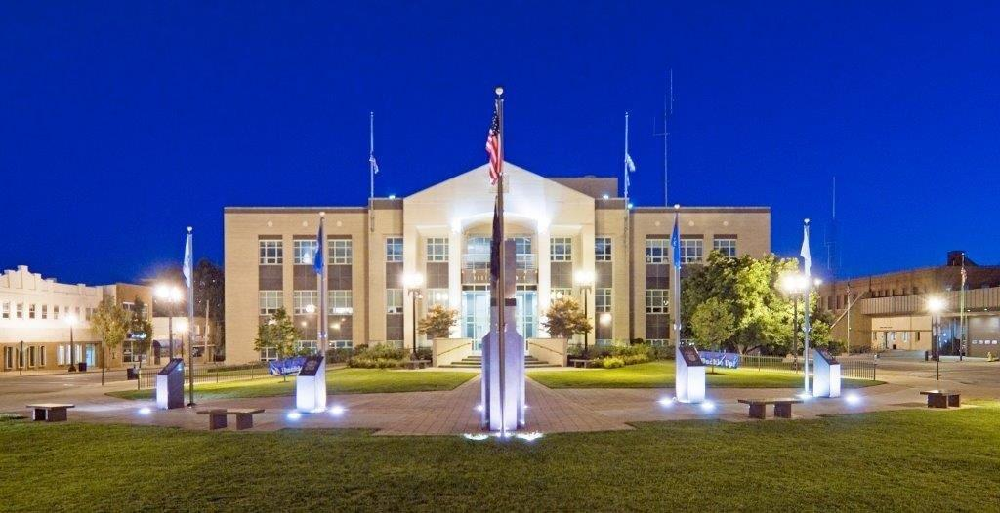  PORTAGE COUNTY VETERANS MEMORIAL BRICK ORDER FORM  The memorial plaza abstractly symbolizes the American National Bird, the Bald Eagle, and as such, symbolizes that our Portage County Veterans are serving the United States of America.  The main monument at the head of the Bald Eagle, represents a commanding officer leading the soldiers, the smaller monuments, into battle and is inscribed with "Lest We Forget."  The five smaller monuments that are spaced out upon the wings of the Bald Eagle, represent the soldiers and the branches of the armed services for which they served: Army, Navy, Air Force, Marines and Coast Guard. Each monument has the appropriate insignia of the branch of the armed service that it represents.  These three elements: the Bald Eagle, the commanding officer and the five soldiers create a place where visitors can walk amongst the soldiers. They can contemplate, reflect, and thank the soldiers for the service they have given and for our freedom, which they have protected.  [Company Name]  - [Subtitle]

Please fill out this order form and send with your payment to: Your Name: ____________________________________________
Portage County Veterans Memorial Address:_________________________________________________
c/o Veterans Services ___________________________________________________
449 S. Meridian Street – 3rd Floor ___________________________________________________ Ravenna, OH 44266 Phone #: ________________________________________________

8X8 Brick ($100) Select either A or B
There can be six (6) lines of text with fifteen (15) characters
(including spaces) per line
- In Memory of (Please indicate if you’d like this inscribed on the brick) YES NO
.15
.15
Name of Veteran:

Rank of Veteran (NOT Pay Grade):

Branch of Service:

Dates of Services:

Please indicate if a War was associated with the Veteran’s service:

- In Support of Portage County Veterans
12X12 Brick ($250) Select either A or B
There can be eight (8) lines of text with fourteen (14) characters (including spaces) per line
- In Memory of (Please indicate if you’d like this inscribed on the brick) YES NO
.15
.15
Name of Veteran:

Rank of Veteran (NOT Pay Grade):

Branch of Service:

Dates of Services:

Please indicate if a War was associated with the Veteran’s service:

- In Support of Portage County Veterans

