Appendix 6A

Water Resources’ Forms and Applications

for Central Sanitary Sewer and Water Improvements

Application to Extend Facilities

Escrow Agreement Example

Performance Agreement Example

Required Submittals

The following are examples of typical forms. These forms are subject to change. Contact the Water Resources Department to assure compliance with current requirements.

*Appendix Revised to Match Proposed Changes 5/12/2021
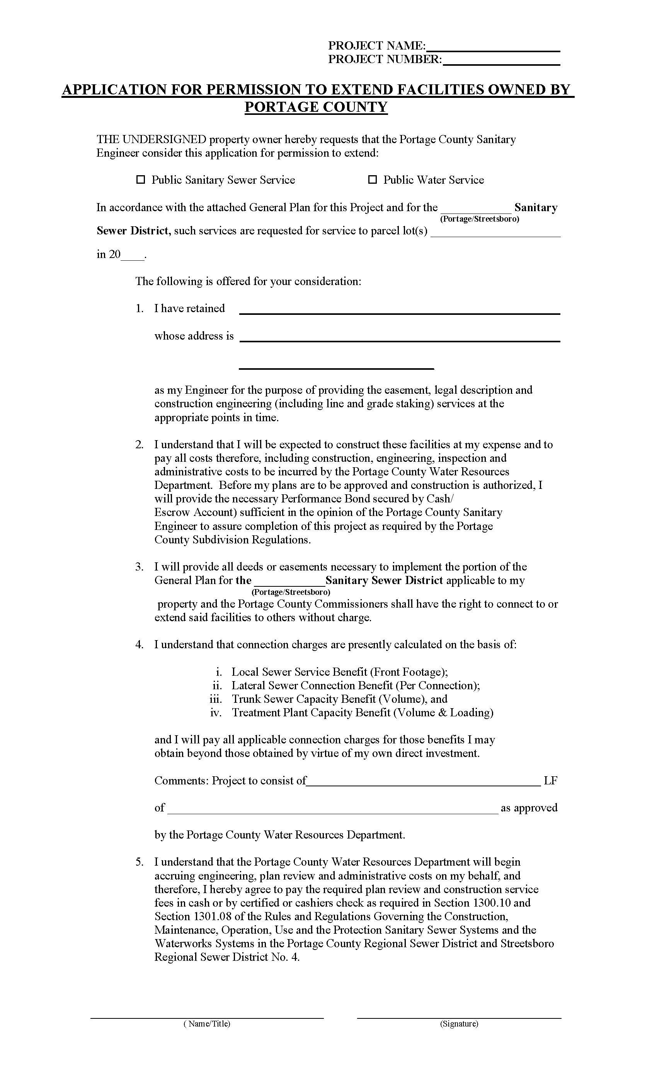
Project Name:PROJECT NAME Click here to enter text.
Project No.: PROJECT NUMBER Click here to enter text.

PERFORMANCE BOND AGREEMENT FOR SANITARY SEWER IMPROVEMENTS

THIS AGREEMENT entered into byOWNER Click here to enter text., hereinafter referred to as the OWNER, and BANK NAME Click here to enter text.(BANK), hereinafter referred to as the BANK, for the benefit of Portage County, concerning the construction of an 8-inch sanitary sewer main, approximately XXX Click here to enter text. linear feet in length and XXX Click here to enter text.linear feet of 6-inch sanitary sewer including all necessary appurtenances, hereinafter referred to as the IMPROVEMENTS. Said IMPROVEMENTS will provide sanitary sewer service to NUMBER OF PARCELS (#) Click here to enter text.parcels situated in the Township of TOWNSHIP Click here to enter text., Original Lot XX Click here to enter text., Portage County, Ohio, and sewer project being known as PROJECT NAME Click here to enter text., County sewer project Number PROJECT NUMBER Click here to enter text..

WHEREAS, the Board of County Commissioners, Portage County, Ohio, hereinafter referred to as the COMMISSIONERS, and the Portage County Water Resources Department, hereinafter referred to as PCWR, have given their final approval subject to completion of all conditions precedent as prescribed by the Rules, Regulations, and Specifications of PCWR and for the aforementioned construction of the required IMPROVEMENTS; and

WHEREAS, the OWNER has agreed to fulfill the requirements of the conditions precedent as described above, and has made a cash deposit with the BANK and has executed a required performance guarantee form in connection with the construction of the IMPROVEMENTS; and

WHEREAS, the BANK has received a cash deposit from the OWNER and has on hand certain funds payable upon satisfactory completion of the IMPROVEMENTS on order by the OWNER, said account being assigned Account No. . The cash deposit received by the BANK from the OWNER are Private funds unless/until the funds are disbursed directly to the COMMISSIONERS and or PCWR for the purpose of completing the IMPROVEMENTS project due to a default by OWNER.

NOW, THEREFORE, it is agreed by and between the parties hereto that the sum of XXX DOLLARS AND XXX CENTS Click here to enter text., ($XXX.XXClick here to enter text.) shall be issued to the COMMISSIONERS and/or PCWR by the BANK for the express purpose of guaranteeing performance of the construction and installation of the aforementioned IMPROVEMENTS.

The above funds held in said Performance Escrow Account will be released by the BANK according to one or more of the procedures listed in items 1, 2 or 3 below:

1. Upon submittal of invoices by the OWNER and approval by the Director of PCWR, funds shall be disbursed direct to contractors or suppliers furnishing material and labor for matters necessary to complete the IMPROVEMENTS and comply with the bond requirements and to pay all costs for services rendered by PCWR and/or its representative.

2. Funds may be disbursed to the OWNER by approval of orders by the Director of PCWR or his agent provided a statement is attached to said orders that all suppliers of labor and material in connection therewith have been paid, or secured to be paid.

3. In the event the OWNER defaults in completing the IMPROVEMENTS to the full satisfaction of the Director of PCWR on or before 18 months from entering this Agreement, except where circumstances and conditions warrant such extension by COMMISSIONER resolution, the Director of PCWR may order the IMPROVEMENTS or uncompleted portion thereof to be completed and the BANK will pay necessary invoices, therefore, to the full extent of the funds remaining in said Performance Bond Escrow Account.

4. That the Director of PCWR or his agent shall be the signatory representative of the COMMISSIONERS regarding approval of invoices to be paid from said Performance Bond Escrow Account except that the COMMISSIONERS shall also approve release of the final ten (10) percent of the moneys remaining in said Performance Bond Escrow Account.

5. Upon release by the COMMISSIONERS of the obligations expressed in the aforesaid bonds, any remaining funds in said Performance Bond Escrow Account shall be disbursed upon order of the OWNER without the requirement of further approval by the Director of PCWR and this Agreement shall cease and become void.

6. It is understood by the parties that payments during the progress of the development work need not be approved by PCWR more frequently than once each month provided that the final payment may require approximately 21 days to process in order to properly record all as-built construction data and accomplish the final inspection.

7. It is understood by the parties that the amount of money established in said Performance Bond Escrow Account is based upon fixed quantities, and unit prices; therefore, payment for any item or items that may have been omitted or deleted or any overages will not be approved for payment until conclusion of the project referred to in the General Sewer Agreement and then only if moneys are remaining in said Performance Bond Escrow Account.

8. No payments will be made from the Performance Bond Escrow Account for materials supplied until such materials have been installed to the satisfaction of PCWR.

9. The BANK agrees to submit to PCWR, an accounting of the funds in said Performance Bond Escrow Account monthly as requested.

The mutual promises contained herein are consideration for the General Sewer Agreement and acceptance hereof by the COMMISSIONERS shall act as consideration from them obligating the parties hereto to said COMMISSIONERS as recited herein.

IN WITNESS WHEREOF, a duly authorized representative of the BANK signed this instrument this _______ day of _____________________, 20____.

BANK: Bank Name: BANK NAME Click here to enter text.
Address: BANK ADDRESS Click here to enter text.
____________________________ City, State, Zip: CITY, STATE, ZIPClick here to enter text.
1st Witness

____________________________ BY: _____________________________________________
2nd Witness
TITLE: ___________________________________________

PHONE NUMBER: _________________________________

IN WITNESS WHEREOF, the OWNERS has signed this instrument this _________ day of _____________, 20___.

OWNER:

_____________________________ ________________________________
1st Witness BUSINESS NAME Click here to enter text.
OWNER NAME, TITLE Click here to enter text.

_____________________________
2nd Witness

Accepted in _________________, _________________(City, State), this ________ day of ______________________20____, by the Board of County Commissioners in connection with and as part of the usual performance bond form as aforementioned.

ALL COMMISSIONER’S SIGNATURES BOARD OF COUNTY COMMISSIONERS,
WITNESSED BY: PORTAGE COUNTY, OHIO

_______________________________ ______________________________________
1st Witness COMMISSIONER Click here to enter text.- President

_______________________________ ______________________________________
2nd Witness COMMISSIONER Click here to enter text. - Vice President

_______________________________________
COMMISSIONER Click here to enter text.- Board Member

REVIEWED BY: APPROVED:

____________________________________ _________________________________________
Assistant Portage County Prosecutor PCWR DIRECTOR, P.E.Click here to enter text./Director
Portage County Water Resources Department

DATE:______________________________ DATE:_________________________________

This document was prepared by the Portage County Water Resources Department.

Project Name: PROJECT NAME Click here to enter text.
Project No.: PROJECT NUMBER Click here to enter text.

PERFORMANCE GUARANTEE FOR SANITARY SEWERAGE IMPROVEMENTS

KNOW ALL MEN BY THESE PRESENT, that CONTRACTOR NAME Click here to enter text., hereinafter referred to as the DEVELOPER, agrees to be held and firmly bound unto the Board of County Commissioners, Portage County, Ohio hereinafter referred to as the COMMISSIONERS, in the full and just sum of XXX DOLLARS AND XXX CENTS Click here to enter text. ($XXX.XXClick here to enter text.) good and lawful money well and truly to be made, does hereby jointly and severally bind the DEVELOPER, the DEVELOPER’S successors, executors and administrators and assigns to the faithful performance and construction of an 8 inch sanitary sewer main and all necessary appurtenances, hereinafter referred to as the "Improvements", for PROJECT NAME Click here to enter text.sewer project, County Project Number PROJECT NUMBER Click here to enter text., hereinafter called the "PROJECT". Said plans and specifications to be prescribed and approved by the Portage County Water Resources Department and subject to a later agreement between the DEVELOPER and the COMMISSIONERS for the construction of said "Improvements" for the "PROJECT".

The faithful performance of this Bond is secured by funds held in a construction escrow account at BANK NAME Click here to enter text. (CITY, STATE Click here to enter text.), hereinafter referred to as the BANK, to be disbursed in accordance with the terms of a later agreement between the OWNER and the BANK for the benefit of Portage County.

The conditions of this obligation are such, that whereas, the DEVELOPER has or will construct said "Improvements" in the PORTAGE COUNTY REGIONAL SEWER DISTRICT OR STREETSBORO SANITARY SEWER DISTRICT NO. 4 Click here to enter text., to provide sanitary sewer service to part of XX.XX Click here to enter text.acres of land located in TOWNSHIP Click here to enter text.Township Lot XXClick here to enter text. , Portage County, Ohio. Said parcel will be provided sanitary sewer service by the "PROJECT" in accordance with the terms of a later agreement between the DEVELOPER and the COMMISSIONERS and with plans and specifications on file with the Portage County Water Resources Department.

WHEREAS, the DEVELOPER shall bear the entire cost and expense of the construction of the "Improvements" until accepted for operation by the COMMISSIONERS.

NOW, THEREFORE, if the DEVELOPER constructs said "Improvements" in full accordance with the approved plans and specifications on file with the Portage County Water Resources Department, and until the COMMISSIONERS accept said "Improvements" the DEVELOPER shall maintain the entire operation in accordance with the rules and regulations of the Ohio Environmental Protection Agency subject to the final approval of all duly authorized Portage County authorities; and the said DEVELOPER shall save harmless the COMMISSIONERS and/or said Sanitary Sewer District and Portage County above mentioned against any and all claims, demands or suits by reason of the construction of the "Improvements" and will indemnify the COMMISSIONERS and/or said Sanitary Sewer District and Portage County against any and all expenses incurred in the completion of the Project and defense of any such suits or any damages, judgments, or decrees, which might be awarded against the COMMISSIONERS and/or said Sanitary Sewer District and Portage County because of any such suit.

IN WITNESS WHEREOF, the DEVELOPER has signed this instrument this ___________ day of ______________, ______.

_____________________________ DEVELOPER: NAME Click here to enter text.
1ST Witness

_____________________________ ___________________________________________
2nd Witness NAME, TITLE Click here to enter text.

